**The First 3-D Printing Device and First Biomimetically Engineered Scaffold benefited Over Thousands of Patients**

1. **Invention of Osteogenic Materials, Biomimetic Scaffold, and the First 3-D Printing Device for Tissue Engineering**
2. **The osteogenic role of Silicon first discovered by Dr. Chou in 1995**

In 1995, in a histological examination of animal tissue with implanted materials under the microscope, Dr. Chou discovered incidentally the dynamic profile at the tissue/implant interface. He noticed the active new bone formation in the area about 2 millimets distant from the interface line. Further SEM and EDAX studies confirmed that Silicon released from the implanted material to the distant zone of tissue strongly corelated to active bone formation.

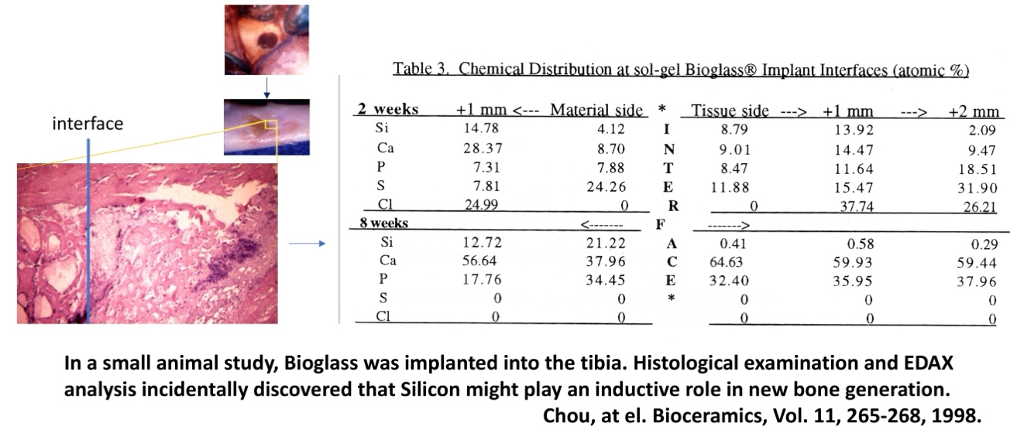

In order to further confirm this exiting discovery, in 1995, Dr. Chou conducted a series of experiments using normal human osteoprogenitor cells and supplemental Si, Ca, and P in different concentrations and combinations. The results showed the osteogenic effect of silicon and synergistic effect of calcium on stimulating bone regeneration via upregulation of osteoprogenitor cell proliferation, alkaline phosphatase activity and mineralization as showing in below figure. This breakthrough finding was the first time to set the foundation of Si and Ca as stimulatory elements in biomaterials for medical applications. This is also the foundation of many of Dr. Chou’s further inventions in bioactive materials and scaffolds for skin wound healing and bone tissue engineering.

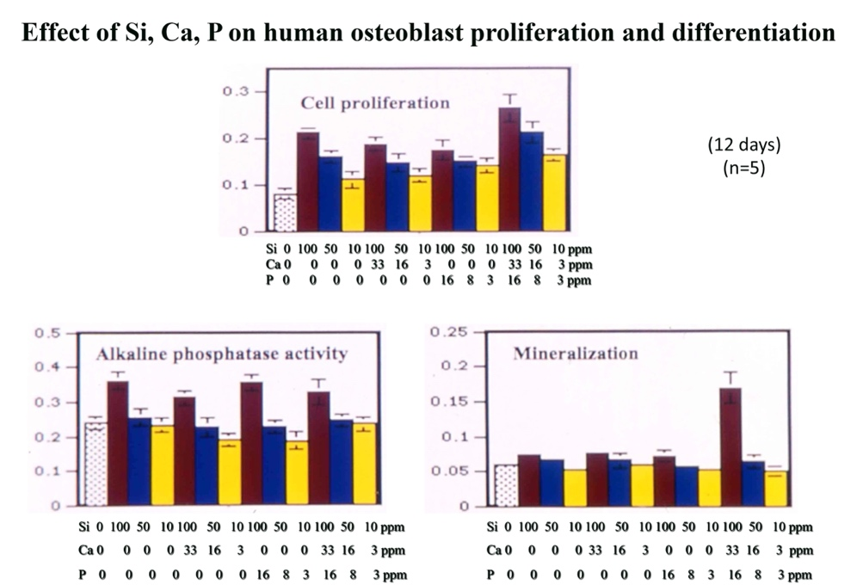

1. **The first biomimetic scaffold designed by Dr. Chou for bone tissue engineering**

For many years, the scaffolds for tissue engineering were designed in a homogenized pattern with certain percentages of pores, which inhibited the cell distribution and blood vessel ingrowth evenly in the entire scaffold, resulting in failures of bone regeneration. Dr. Chou made the first biomimetic design of bone tissue engineering scaffold in 1995 with the specific boxes for bone tissue nucleation, specific channels for cell seeding and specific channels for blood vessel ingrowth. This unique design of scaffold internal geometry would be able to facilitate the cell seeding, cell distribution, bone growth and blood vessel ingrowth, allowing the bone regeneration for large defect of the bone.

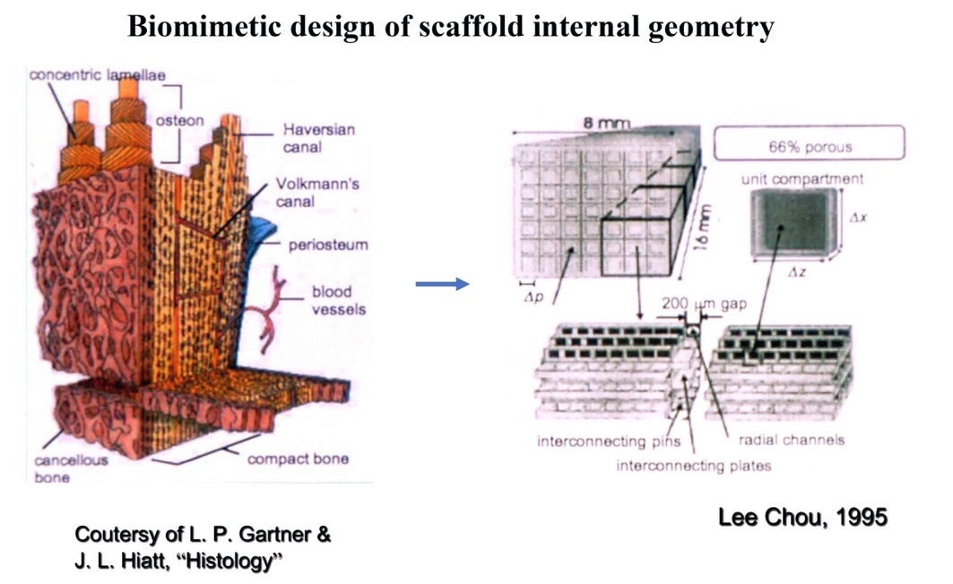

1. **The first 3-D printing device developed by Dr. Chou for tissue engineering**

After discovery of osteogenic materials and biomimetic design of scaffold internal geometry, in order to fabricate the sophisticated scaffold at the scale of micrometers, Dr. Chou developed the first 3-D printing device for tissue engineering in 1995. At that time, any commercial 3-D printing device was not available for tissue engineering. With this hand-made 3-D printing device as showed below, the osteogenic scaffolds with biomimetically designed internal geometry were successfully fabricated.

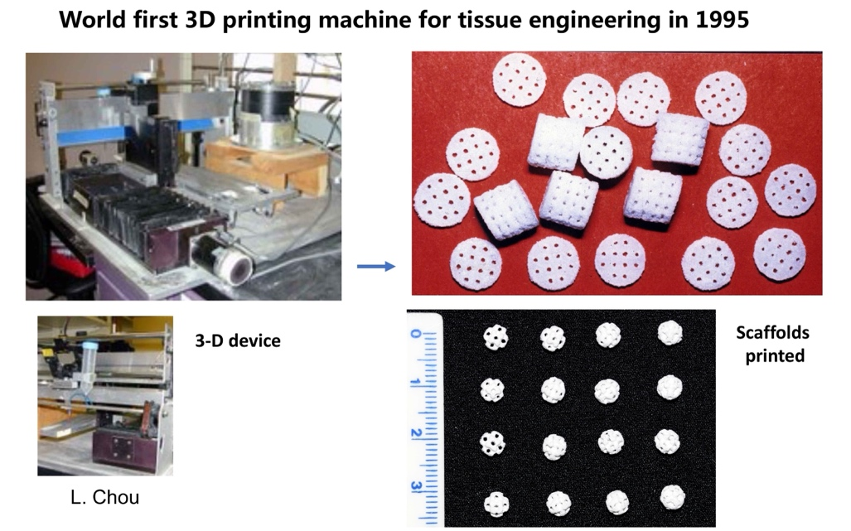

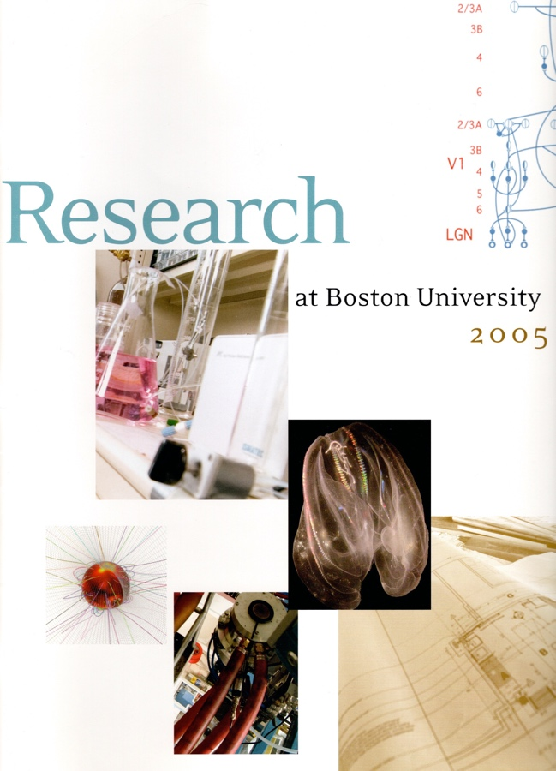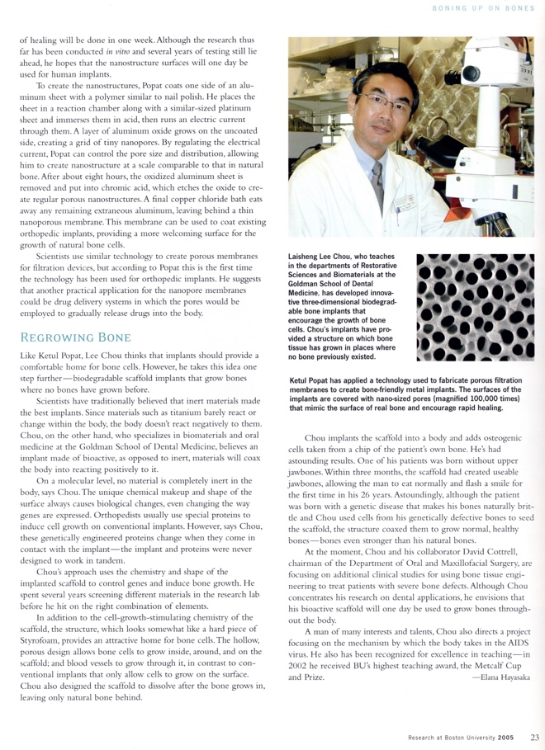

1. **In Vivo Studies of Bone Tissue Engineering**
2. **The first engineered human bone tissue**

In 1996, Dr. Chou successfully engineered the human bone using the scaffold with his innovative osteogenic materials and biomimetic design of internal geometry. A large scaffold seeded with human osteoprogenitor cells derived from a healthy patient donner was implanted into SCID mice under Institution IACUC approval. As showing below figures, at 6 weeks of implantation, bone tissue regrowth throughout the entire scaffold of 1 cm in size. High magnification showed high quality of woven bone (primary bone) formation, Haversian structure, blood vessel ingrowth, and degradation of scaffold materials. **This was the first success in the world in regenerating human bone in vivo.**

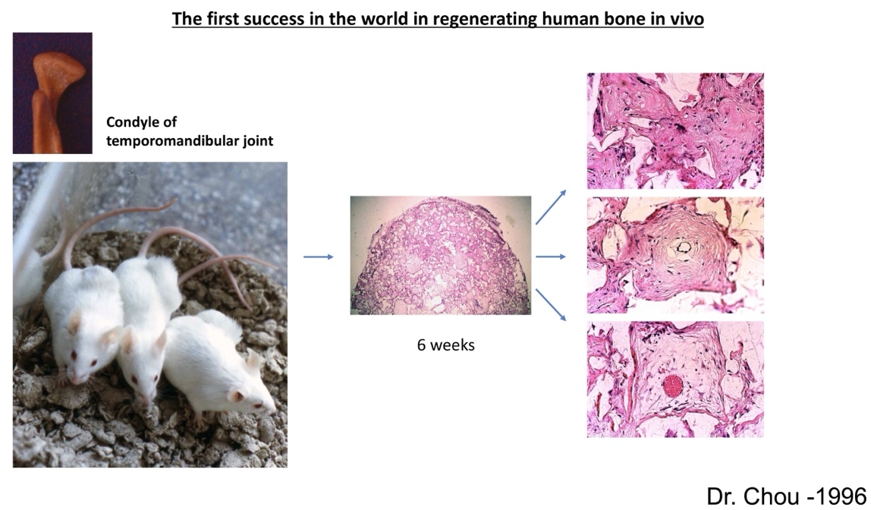

1. **The first success in repairing a segmental bone defect**

One of the major challenges in bone tissue engineering is to repair the segmental defect of load-bearing bones. In 2002, Dr. Chou first made a breakthrough work in reconstructing the mandible in a dog with segmental defect. Combined with his four innovative technologies: osteogenic active biomaterial, biomimetic design of scaffold internal geometry, 3-D printing, and autologous osteoprogenitor cell technology, Dr. Chou successfully regenerated the new mandible in a dog with over critical sized segmental defect.

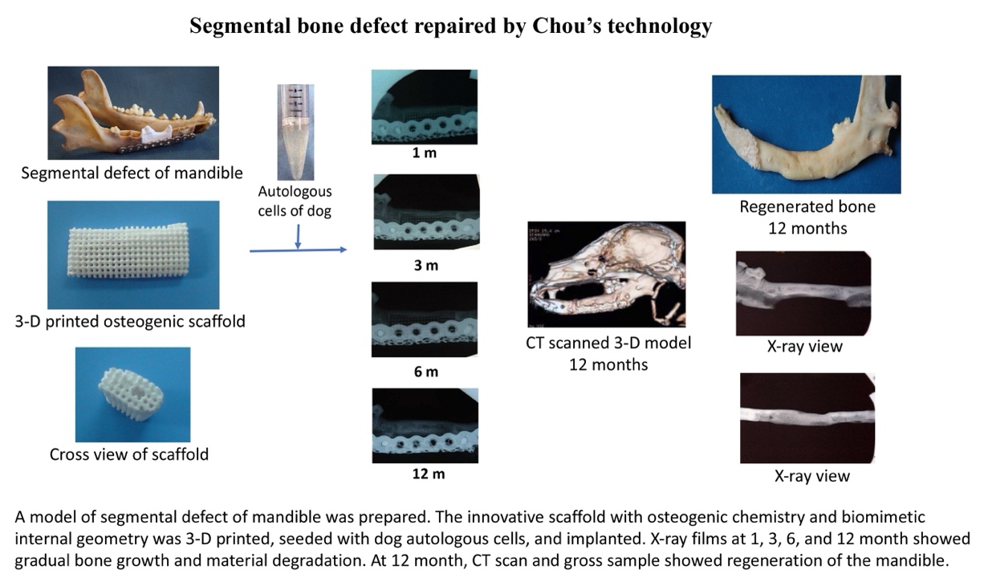

1. **Translating Inventions into a Series of Products Named OSTEOBONE**

Dr. Chou has translated his discoveries and inventions into a series of products named **OSTEOBONE** for medical application.



1. **Selected Patients Treated with OSTEOBONE Bone Scaffold Products**
2. **The first patient with an over 25-year long-term follow-up after treatment with Chou’s innovative technique in 1998**

This was the first case successfully treated by Dr. Chou’s innovative technologies of osteogenic materials, biomimetic design of scaffold internal geometry, 3-D printing device and patient’s autologous osteoprogenitor cells under the IRB approval in 1998, as otherwise no other effective choice of treatment was not available.

This patent of 26 years of age suffered with benign dominant osteopetrosis with significantly atrophy of his maxilla without posterior teeth. After his maxillary bone was regenerated, dental implants were placed with full function. Now, this patient has been followed up for over 25 years. All implants placed remain functional, indicating the long-term success. *(Patient identity is intentionally concealed)*

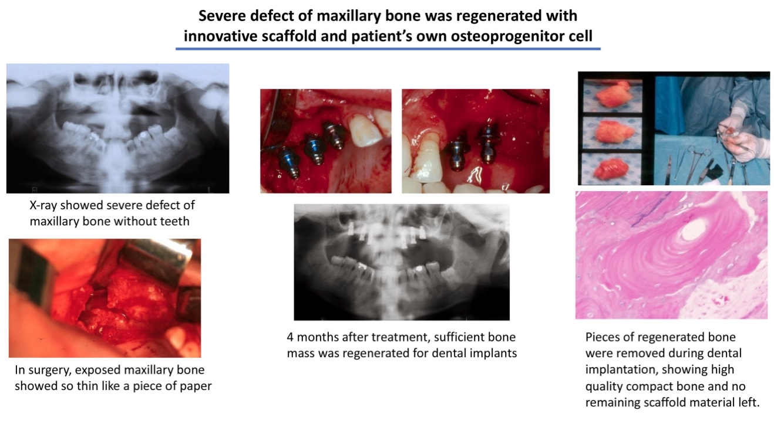

1. **The second patient with an over 25-year long-term follow-up after treatment by Chou’s innovative technique in 1999**

This was the second case successfully treated by Dr. Chou’s inventive technologies of osteogenic materials, biomimetic design of scaffold internal geometry, 3-D printing device and patient’s autologous osteoprogenitor cells under the IRB approval in 1999.

This patent of 45 years of age suffered with benign dominant osteopetrosis with significantly atrophy of his mandibular bone without any functional tooth. He also suffered with frequent fractures of his mandibula, so needed the external fixations with four external metal pins. After his mandibular bone was regenerated, fracture never occurred without external fixation. Now, this patient has been followed up for over 25 years. His masticatory function remains completely normal without any external fixation, indicating the long-term success. *(Patient identity is intentionally concealed)*

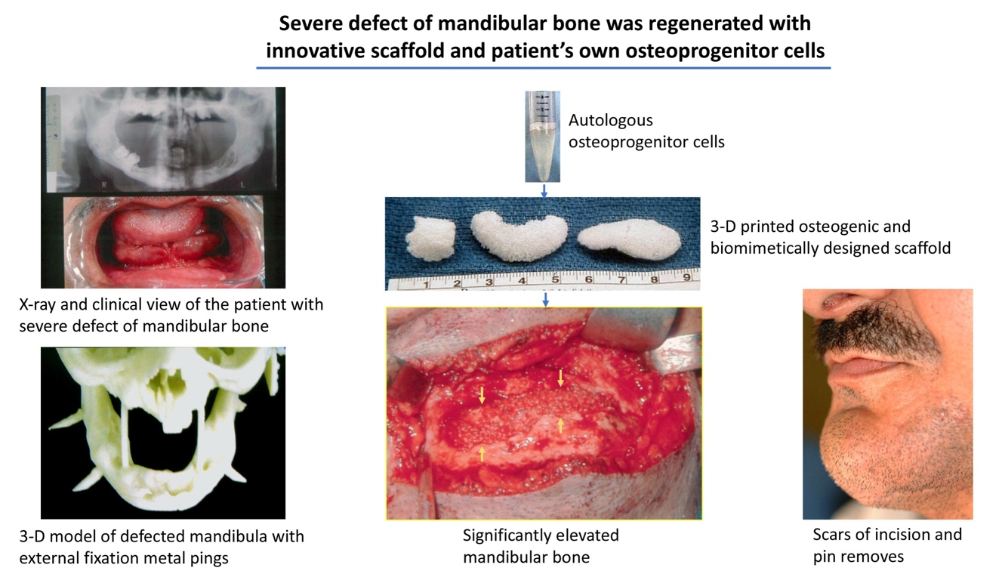

1. **Large mandible defect successfully treated with OSTEOBONE**

This patient suffered with massive lesion of fibrous dysplasia of mandible. Routinely, a mandibulectomy would be performed in surgical removal of the lesion because of the size of defect. With the treatment of **OSTEOBONE**,the massive defect was completely filled with newly generated bone in 12 months. His mandible was saved to secure the quality of his life. *(Patient identity is intentionally concealed)*

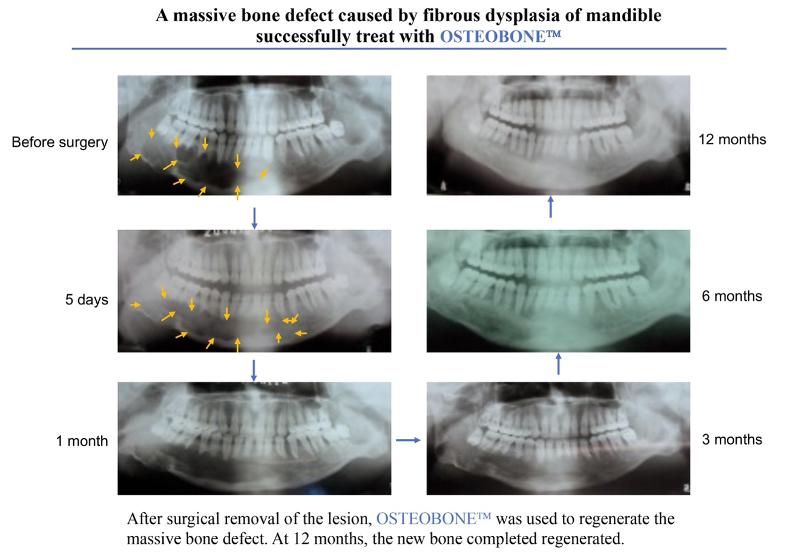

1. **Bone donor site repaired with OSTEOBONE**

This patient was one of the large-scale clinical trials for treatment of the bone donor site defects with **OSTEOBONE** in comparison to the conventional treatment with hydroxyapatite (HA). The levels of material degradation and new bone formation are the measures of success. According to the FDA regulation, the trial was conducted by the independent multi-centered institutions. The results showed that **OSTEOBONE** was significantly superior than HA in both material degradation and new bone formation (P < 0.0001). This patient presented below is an example of the trial group. *(Patient identity is intentionally concealed)*



1. **Bone defect after benign bone tumors treated with OSTEOBONE**

This patient was one of the large-scale clinical trials for treatment of defects after benign bone tumor removals with **OSTEOBONE** in comparison to the conventional treatment with hydroxyapatite (HA). The levels of material degradation and new bone formation are the measures of success. According to the FDA regulation, the trial was conducted by the independent multi-centered institutions. The results showed that **OSTEOBONE** was significantly superior than HA in both material degradation and new bone formation (P < 0.0001). The patient presented below is an example of this trial group. *(Patient identity is intentionally concealed)*

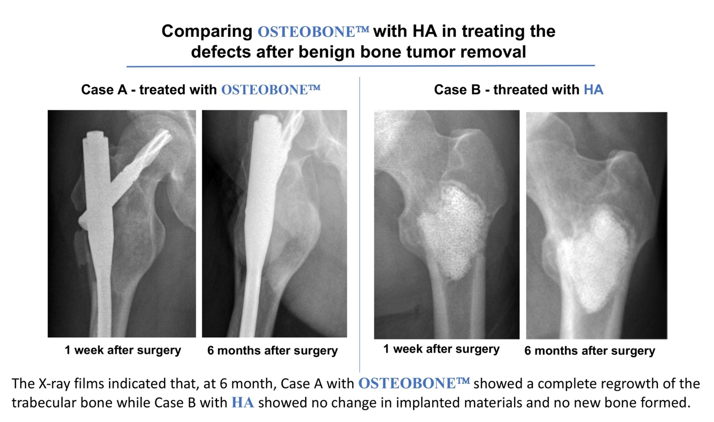

1. **Bone fracture treated with OSTEOBONE**

This patient was one of the large-scale clinical trials for treatment of defects bone fractures with **OSTEOBONE** in comparison to the conventional treatment with hydroxyapatite (HA). The levels of material degradation and new bone formation are the measures of success. According to the FDA regulation, the trial was conducted by the independent multi-centered institutions. The results showed that **OSTEOBONE** was significantly superior than HA in both material degradation and new bone formation (P < 0.0001). The patient presented below is an example of this trial group. *(Patient identity is intentionally concealed)*



1. **Patents Covering the Invention and Production of OSTEOBONE**

Human Bone Tissue Engineering Scaffold and Its Preparation and Application. China. Publication Number: CN1294885C, Patent Number: ZL 01113076.8, 2007.

Bone Tissue Repair Material Delivery Device for Minimally Invasive Surgery. Publication Number: CN2840998Y, Patent Number: ZL200520076281.5, 2006.

Human Bone Tissue Engineering Scaffold and Its Preparation and Application. United Kingdom, France, Germany, Belgium, Spain, Sweden, and Italy. Publication number: 02742644.4-2107, Patent Number: 1426066. 2010.

Human Bone Tissue Engineering Scaffold and Its Preparation and Application. Japan. Publication Number: 2003-501511, Patent Number: 4391815, 2009.

Human Bone Tissue Engineering Scaffold and Its Preparation and Application. Russia. Publication Number: 200313782.3, Patent Number: 2308974, 2007.

Ingredient Tanks for Production of Bone Repairing Materials. China. Publication Number: CN219744676U, Patent Number: ZL202320694223.7, 2023.

Crusher for Production of Bone Repairing Materials. China. Publication Number: CN219744896U, Patent Number: ZL202320382589.0, 2023.

Scaffold for Repairing Large Mandible Defect. China. Publication Number: CN1143668518B, Patent Number: ZL202111679163.3, 2022.

A Cutting Device for Bone Repairing Materials. China. Publication Number: CN214724555U, Patent Number: ZL202023267401.3, 2021.

Tissue Engineering Scaffold for Repairing Large Skull Defects. China. Publication Number: CN215019736U, Patent Number: ZL202023192408.3, 2021.

A Reinforcement Device for Tissue Engineering Scaffold for Repairing Large Skull Defects. China. Publication Number: CN215019737U, Patent Number: ZL202023192409.8, 2021.

Bone Repairing Scaffold Material Mixing Device. China. Publication Number: CN210906376U, Patent Number: ZL201921321524.5, 2021.

A Spray Humidifying Device for Bone Repairing Materials. China. CN210906606U, Patent Number: ZL201921321538.7, 2020.

Cuttable Bone Scaffold. China. Publication Number: CN207445077U, Patent Number: ZL201720363539.2, 2018.

Operation Cabinet for Bone Repairing Scaffolds. China. Publication Number: CN206840152U, Patent Number: ZL201720363587.1, 2018.

Humidifying Spray Device for Bone Tissue Defect Filling Materials. China. Publication Number: CN206838335U, Patent Number: ZL201720346785.7, 2018.

Scaffold for Bone Repairing. China. Publication Number: CN207462190U, Patent Number: ZL201720346757.5, 2018.

Surgical Instruments for Bone Defect Volume Measurement and Repairing. China. Publication Number: CN201768022U, Patent Number: ZL201020286208.1, 2011.

Improved Bone Tissue Repairing Material Delivery Device for Minimally Invasive Surgery. China. Publication Number: CN201019818Y, Patent Number: ZL200720033333.X, 2008.

1. **Articles Published by the Independent Clinicians Who Used OSTEOBONE in Their Clinics with Successful Outcomes**

**To be added**